String functions in C programming language.

There are many important string functions defined in "string.h" library.

No | Functions | Description
1. | strlen(string_name) | returns the length of string name.
2. | strcpy(destination, source) | copies the contents of source string to destination string.
3. | strcat(first_string, second_string) | concats or joins first string with second string. The result of the string is stored in first string.
4. | strcmp(first_string, second_string) | compares the first string with second string. If both strings are same, it returns 0.
5. | strrev(string) | returns reverse string.
6. | strlwr(string) | returns string characters in lowercase.
7. | strupr(string) | returns string characters in uppercase.
1.strlen(string_name).

returns the length of string.

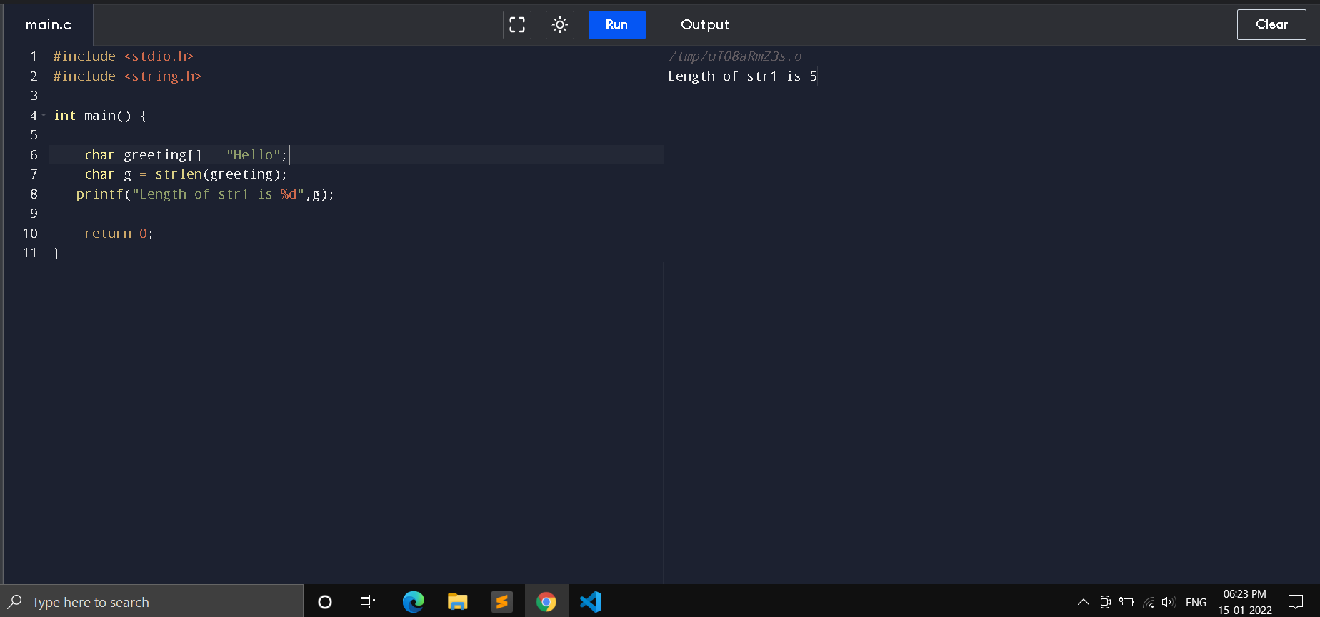

2.strcpy(destination, source).

copies the contents of source string to destination string.

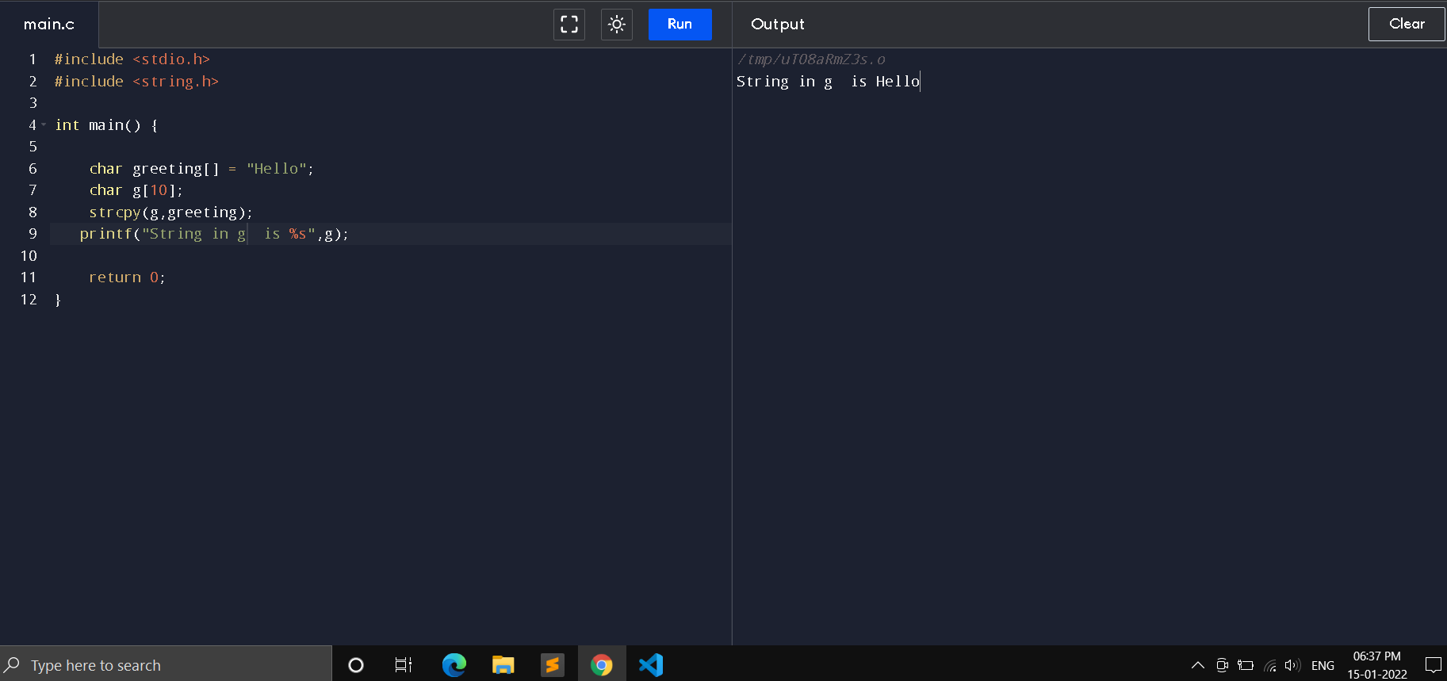

3.strcat(first_string, second_string)

concats or joins first string with second string. The result of the string is stored in first string.

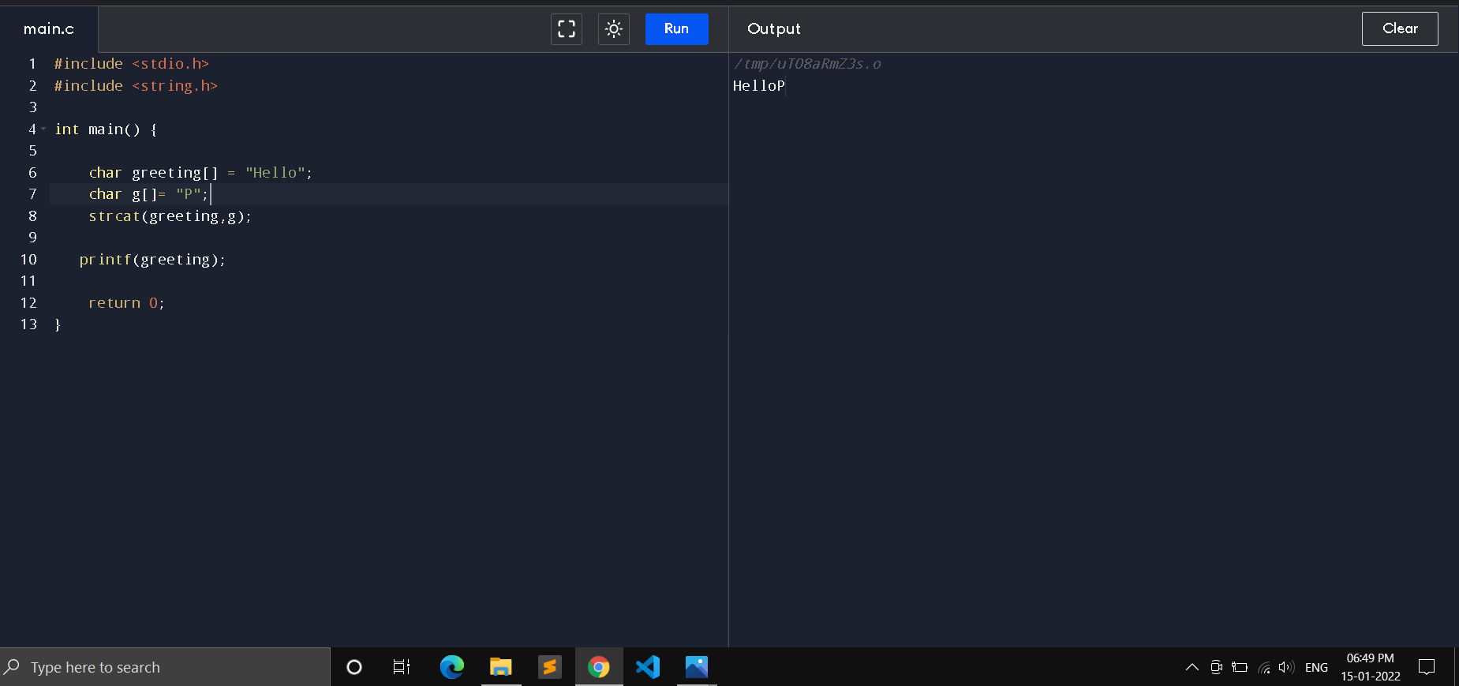

4.strcmp(first_string, second_string)

compares the first string with second string. If both strings are same, it returns 0.
